Unit 9 Lesson 4
Name(s)_______________________________________________ Period ______ Date ___________________

CrossTab

1. Crosstab - Use the “Words” dataset
Use: Length & Part of Speech
- Chart - Copy and paste the chart you created in the space below
- 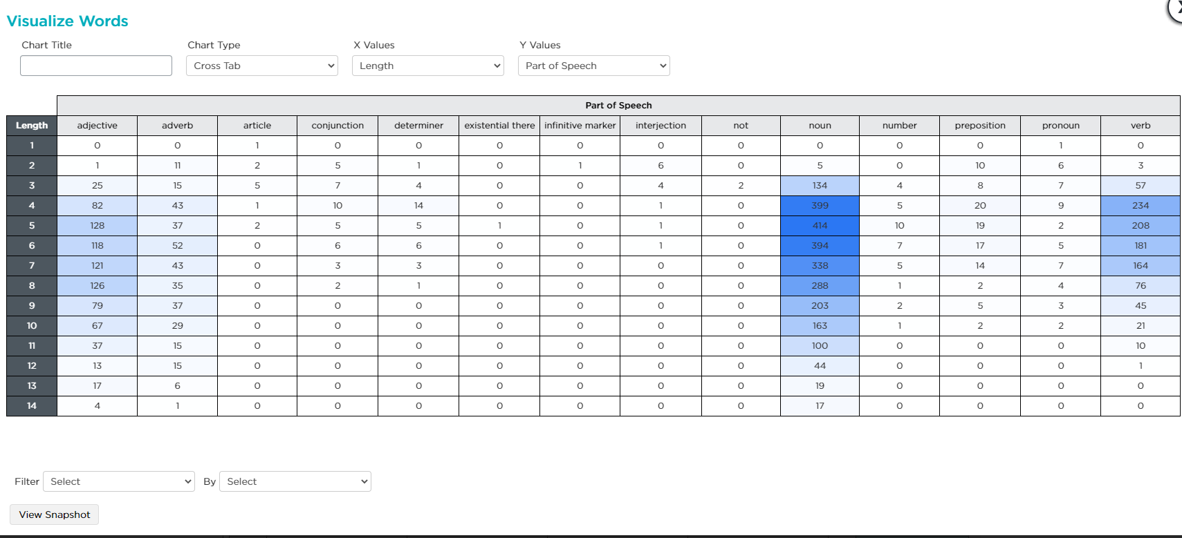
- Which part of speech shows up most often in this data set? Noun
- Which part of speech seems to be longest, on average? Noun
- Which part of speech seems to be shortest, on average? Article
Activity
Guide
-
Exploring
Two
Columns
- About how long is the "typical" noun? How can you tell? 4 letters because that’s what the graph says

2. Crosstab - Use the “Favorite Classes” dataset
Use: Grade & Favorite Class
- Chart - Copy and paste the chart you created in the space below
- 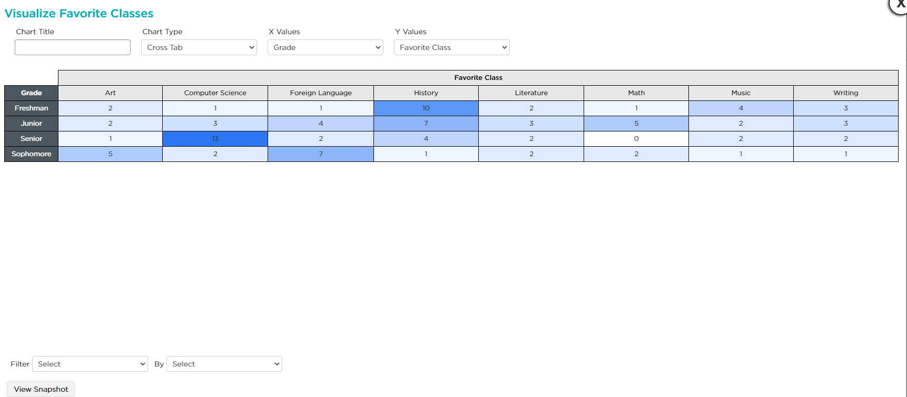
- Which class do Seniors like the most? Computer Science
- Which grade likes History the most? Freshmen
- What is one other interesting pattern you can see in this diagram? Juniors don’t strongly prefer one class
Computer Science Principles 1 Unit 9 Lesson 4

Scatter

1. Scatter - Use the “US States” dataset
Use: Median Household Income & Percent Adult College Graduates
- Chart - Copy and paste the chart you created in the space below
- 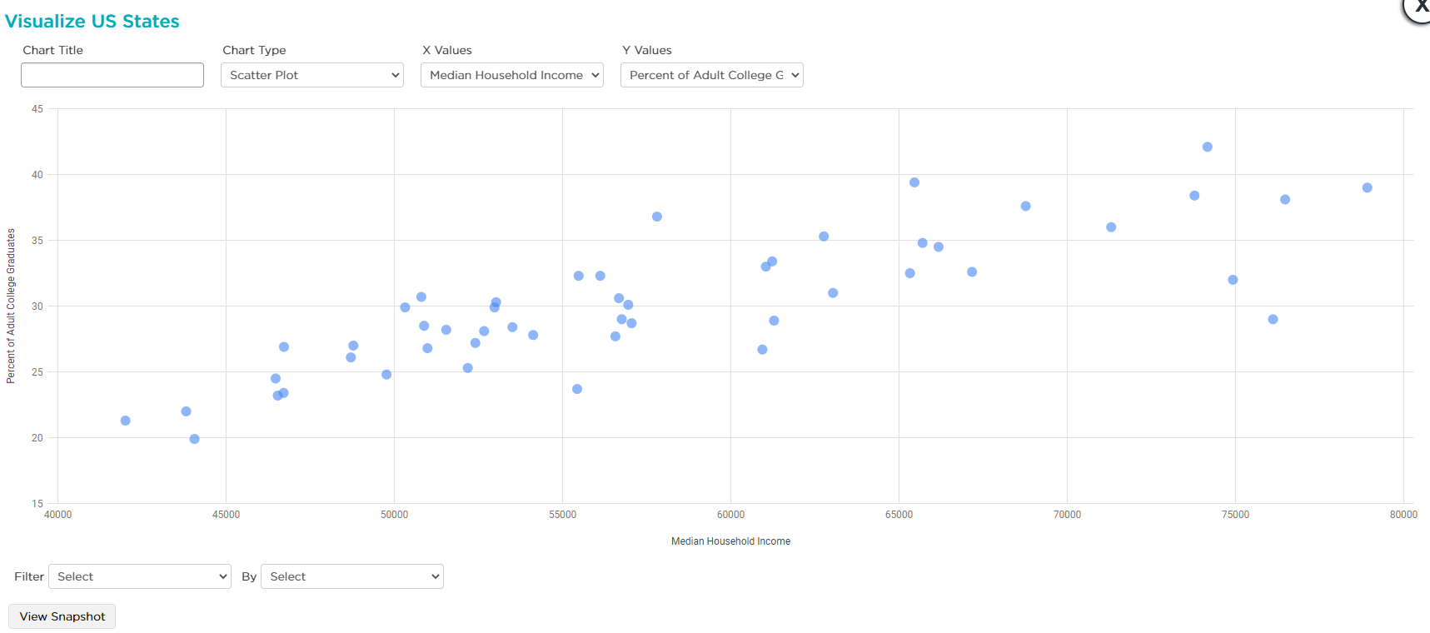
- What is the range of incomes on this chart? 4200-78000
- What is the range of percentages of adult college graduates? 19-40%
- Do you see a relationship between income and percent of adult college graduates? What does the relationship look like? The more percent of adult college graduates the higher the income is

3. Scatter - Use the “US States” dataset
Use: You pick the columns to compare
In the States table find a combination of columns in a Scatter Plot that you think show an interesting pattern
- Chart - Copy and paste the chart you created in the space below
- 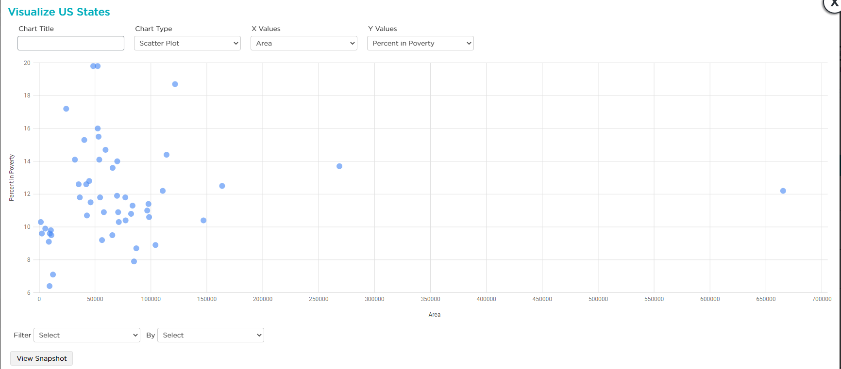
- What is the pattern that you observe in this data? It is very far on the left
- Describe what this pattern might mean or indicate. If a state is bigger then it might have more people in poverty
- Usually we can't be sure whether the pattern we observe in a scatter chart (a correlation) means that one of the columns is causing the other. Give one way you might do more research to try to investigate the cause of the pattern you found. One way is to look at where exactly the people in poverty live, like in rural or urban areas
Computer Science Principles 2

